You can choose to submit either A6 (worth 150 points), AD6 (worth 180), or both (worth 180) for this assignment you will get a score for the assignment either 150 points base or 180 points base.
A6
Modify the attached Tip Calculator app to perform calculation without the “Calculate” button. So you need to use proper listeners to perform calculation whenever the user modifies the bill amount or changes the customer tip percentage.
The following are some of the screen shots of the app.
We should see the right side of picture when the app starts. | 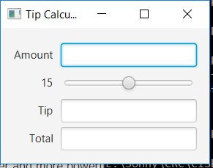
When we start to type in number the app starts to calculate and display. | 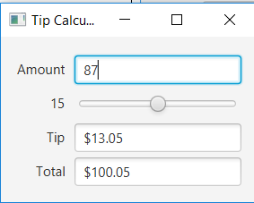
When you type in anything other than number the “Amount’ field will display “Enter Amount”. | 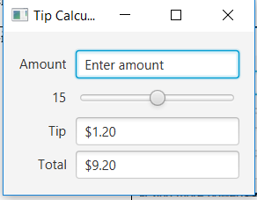

You need to know techniques in chapter 1~ 13. The main skills for this assignment are in Ch13. You can also use more advance skills to do this assignment.
This assignment comes with a CISP401V11A6.zip file. It includes five files (four .class files and one .fxml file.) The .class files are executable files. You can place them in a sub folder (directory). Bring up a command prompt and go to the sub directory, type “java TipCalculator “ in the sub directory and hit “Enter” key. You should see the program run. If you put in proper information you should get to the result in the following pictures.

Please document the files properly and zip your .java and .fxml files into a proper named zip file for an assignment (refer to the assignment section of the class syllabus) and submit it to the A6 folder of the Canvas Website.

Worth 150 points

AD6
There is a large variety of formats for dates in use, which differ in the order of date components (e.g. 31/05/2018, 05/31/2018, 2018/05/31), component separators (e.g. 31.05.2018 vs. 31/05/2018), whether leading zeros are included (e.g. 31/5/2018 vs. 31/05/2018), whether all four digits of the year are written (e.g., 31.05.2018 vs. 31.05.99), and whether the month is represented in Arabic or Roman numerals or by name (e.g. 31.05.2018, 31.V.2018 vs. 31 May 2018).

Three of the more common formats are 04/05/2018, 4/5/2018 and April 5, 2018.

Write a Java application that will read less than or equal to 20 dates in the first format (04/05/2018) or second format (4/5/2018) and convert them in the third format (April 5, 2018). Before the 20 inputs, the program should allow user to terminate the input by inputting 9999/. Whether the program is exit by hitting the 20 inputs or by the 9999/, the program will print out a tabulate conversion list before the ending of the program.

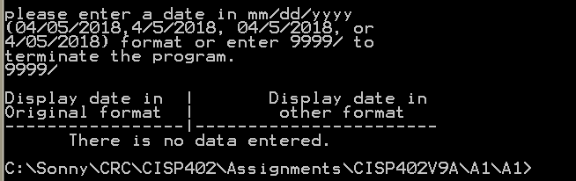  When we enter 9999/ the program should display There is no data entered information | 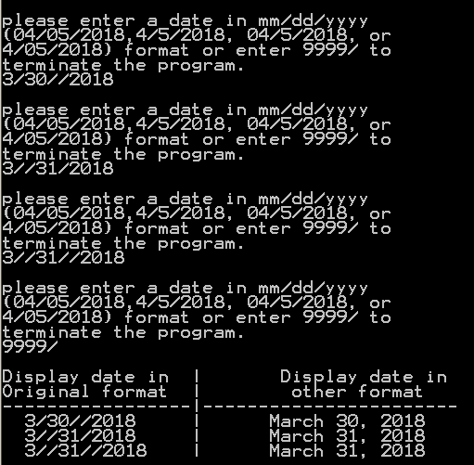  The program should allow some extra “/” within the day, month and year.
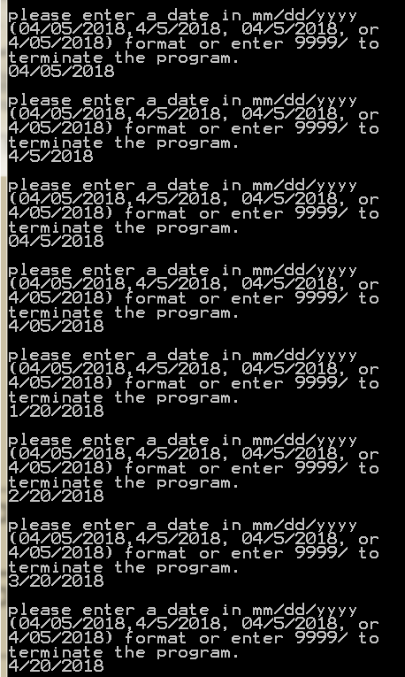
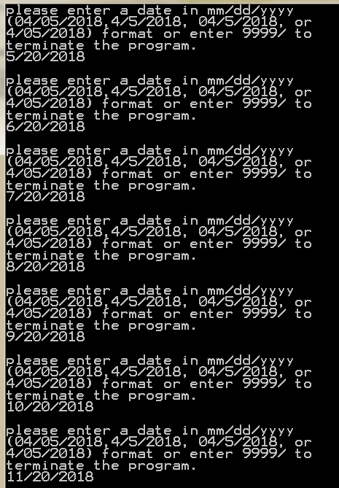
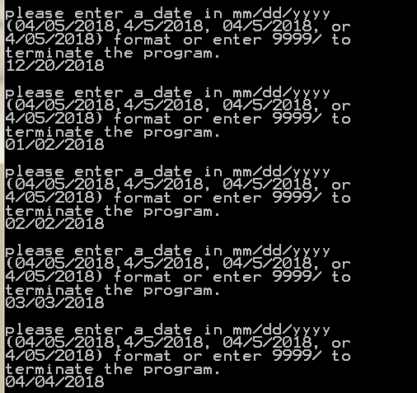

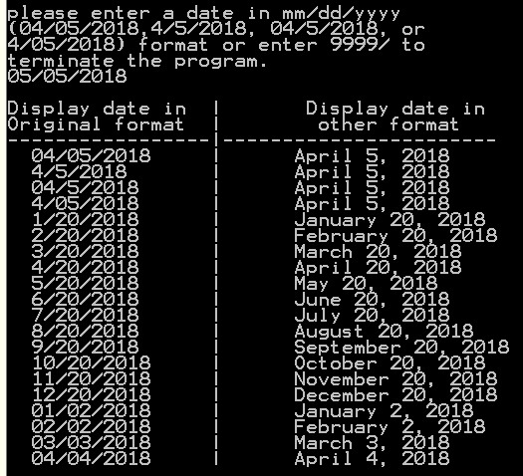
After entering 20 dates information the program will generate a screen as on the left.
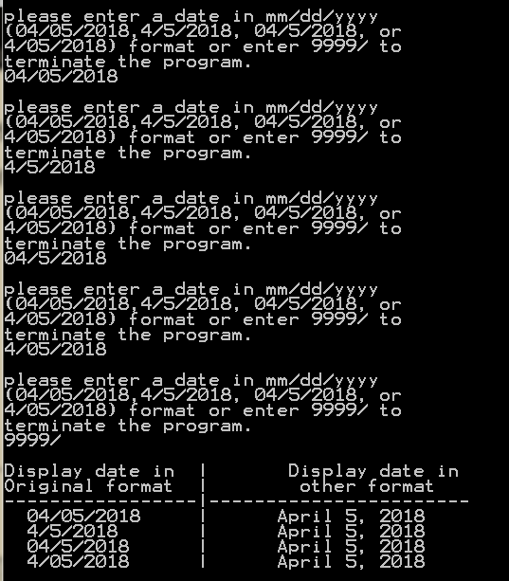
When we enter 04/05/ 2018, 4/5/2018, 04/5/ 2018, 4/05/2018 and 9999/ the program will display a screen on the left.
You need to know techniques in chapter 1~ 14. The main skills for this assignment are in Ch14. You can also use more advance skills to do this assignment.

This assignment comes with a CISP401V11AD6.zip file. It includes one file (DateConversion.class). The DateConversion.class file is an executable file. You can place DateConversion.class in a sub folder (directory). Bring up a command prompt and go to the sub directory, type “java DateConversion” in the sub directory and hit “Enter” key. You should see the program run. If you put in proper information you should get to the result in the above pictures.
Please document the files properly and zip your .java into a proper named zip file for an assignment (refer to the assignment section of the class syllabus) and submit it to the A6 folder of the Canvas Website.

Worth 180 points

